2026 SHED MOCK PHYSICS PAPER 1
PROVISIONAL MARKING KEY
Section A (70 Marks)
1(a) The net workdone by the net force on a rigid body is equal to the change in kinetic energy of the body (1)
(b) i. $50×{10}^{3}Ω±5\%$
(1) (1) (1)
ii. The tolerance would increase(1)

(c) Point L = Elastic limit, deformation point, Fracture point (1) (any one)
Section LT = Plastic region, Fracture region, deformation region (1) (any one)
(ii)The extension on an elastic material is directly proportional to the force applied provided that the elastic limit is not exceeded
- a. By sliding/moving the lens in and out (1)
By moving the camera close or away from the object (1)
b. (i)Transverse waves
(ii) Wave A
(iii)Because it has more complete waves within the same period as compared to wave B/Because it has more crests and troughs (1)
c. Light rays from a near object(1) are converged(1) so that they appear to come from a virtual imabe(1).Then the eye focusses this image on the retina(1)

- a. Radioactivity is the disintegration of the unstable nucleus while nuclear radiation is the emission of particles and energy from the nucleus (1)
- X-rays can only pass through flesh and not through a dense material like a bone(1). Where a bone has a fracture, it creates a passage for x-rays (1) thereby identifying the fractured part(1)
- Amplitude of the vibrating body (1)
Distance from the vibrating body (1)

4 a. A machine with a higher mechanical advantage also has a high frequency (1)
OR The mechanical advantage of a machine is directly proportional to its efficiency.
b. Acceleration = (v-u)/t (1)
= (5m/s -0m/s)/2s (1)
= 2.5m/s² (1)
c. Temperature (1) , Volume (1)
- a.
- Capacitor
- By increasing number of plates
By reducing the distance between the plates

b.
Units of electricity = 1.5Kw X (30/60)h (1)
= 1.5Kw X 0.5h = 0.75KwH
Cost = 0.75 X K140.00 (1)
= K105.00 (1).

- a. i. Vernier calliper
- Main Scale Reading = 10.5mm (1)
Vernier Scale Reading time Count rare = 7mm x 0.1mm = 0.7mm (1)
Diameter 0.7mm + 10mm = 10.7mm (1)

b - Correct positioning of the eye (1)
- Being accurate in reading the values from the measuring instrument (1)
c. Nuclear Fission(1) abd Nuclear fusion (1)
7 a.
  - In digital circuits, information is transmitted through electric signals while in analogue circuits, information is transmitted through electric pulses of different magnitudes (1)
  - In digital circuits information is transmitted in binary format while in analogue circuit information is transmitted through continuous varying voltages (1)
  - Digital circuits are easy to design while analogue circuits are complex to design (1)
  - Digital circuits are more sensitive to change while analogue circuits are less sensitive to change (1)
b. Zener effect is the breaking down of a p-n junction diode due to huge current(1)
c. Leaking magnetic flux that are induced into any conductive part of the transformer produces eddy currents (1) which in turn produces heat(1)
- a. Water is pushed backwards(1) and in turn it pushes the boat forward(1) as it tries to occupy its original position (1)
b. m₁v₁ = m₂v₂ (1)
6kg x Y = 0.02Kg x 400m/s (1)
Y = (0.02Kg x 400m/s) /5Kg (1)
= 1.6m/s (1)
- a Crow bar (1)

b. Load x Load arm = Effort x effort arm
900N x Y = 300N x 3m (1)
Y = (300n x 3m) /900N (1)
Y = 1m (1)
- Fishing rod, Bicycle gear (2)
10. a. The process of splitting a vector into its horizontal and vertical components (1)
b. The two vectors are firstly re drawn (1) in form of head to tail at an angle (1). The line that completes the vector diagram to form a triangle becomes the resultant of the two forces (1)
c. Using Lens Formula
$$\frac{1}{f}=\frac{1}{u} +\frac{1}{v}$$
$\frac{1}{4}=\frac{1}{8} +\frac{1}{v}$ (1)
$\frac{1}{v}=\frac{1}{4}-\frac{1}{8}$ (1)
$\frac{1}{v}=\frac{1}{8}$ (1)
$v=8 cm$ (1)

- a.
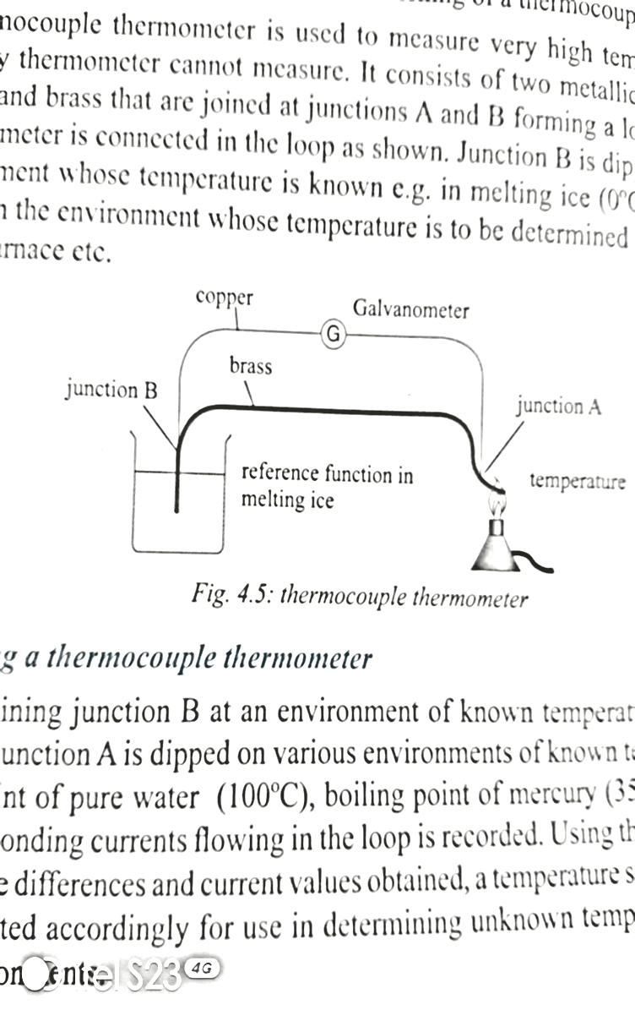
Correct diagram 1 mark
Any three correct labels 1 mark

- One junction is put into contact with a substance of known temperature while the other junction is put in contact with a substance whose temperature is to be measured(1). Current flowing in the loop is recorded(1),
Different temperatures will have corresponding current values (1)and this is used to determine the unknown temperature (1)
b. Air inside the balloon is heated (1) and it expands(1). This makes the volume of the balloon to increase (1) thereby reducing its density(1) and balloon flies.
12. (a) Clothes are held around a drum(1). The drum is then rotated several times (1). As the drum rotates, it expels water from the clothes(1) and the water escapes through the holes on the drum(1). This makes the clothes to dry(1).
(b) Insulators have a wide forbidden gap(1). Increasing temperature provides kinetic energy to the electrons in the valence band(1), but the energy is not enough to excite electrons(1) to cross the forbidden gap (1)and hence insulators do not conduct(1)
13. (a)
2m
1 mark for the arrowed line
1 mark for indicating any magnitude e.g 2 meters
On Paper, a vector is represented using a directed line segment/arrowed line(1). The arrow indicates direction (1) while the length of the line represents the magnitude of the vector(1).
(b). The decay tooth is removed (1). A filling material which has the same coefficient of expansion as the tooth(1) is firstly heated (1) and placed in the cavity(1). As it cools, it hardens (1) and fills the gap(1). When the temperature changes, they both expand together(1)

